Supporting Multiple Equipment Enumeration Approaches in the
Military Simulation Description Language (MSDL)

Lee W. Lacy, Ph.D., CMSP
Dynamics Research Corporation
3505 Lake Lynda Drive, Suite 100
Orlando, FL 32817
407-965-2804
llacy@drc.com

Richard Byrd
Northrop Grumman
12000 Research Pkwy, Ste 231
Orlando, FL 32826
407-306-4014
richard.l.byrd@lmco.com

Keywords:
MSDL, Enumeration
ABSTRACT: MSDL files contain equipment descriptions that identify platform types (e.g., M1A1 tank). The Distributed Interactive Simulation (DIS) Enumeration document specifies a popular encoding scheme for uniquely identifying equipment types. However, a variety of schemes should be supported by MSDL. If the identification of the utilized scheme is not standardized within the specification, it will be difficult for heterogeneous simulation initialization tools to map the equipment identification information in an MSDL file to the internal equipment types supported by simulations. The MSDL specification should allow for specifying the enumeration approach being used. It should also support identification methods that use multiple parameters. The referenced enumeration descriptions should meet specified requirements to be considered valid. This paper presents a candidate approach for standardizing the description of enumerations, referencing multiple enumeration description approaches, and identifying individual enumerations.

1. Introduction
The Military Simulation Description Language (MSDL)[1] provides a means for interchanging initial conditions and state information for a military simulation. The standard is documented in a Microsoft Word file and is formalized in companion XML schema files. XML interchange files for simulation must deal with both syntactic and semantic issues [2]. This paper describes the existing challenges in specifying equipment types, suggests requirements for a solution, and proposes a solution that satisfies the requirements.

2. Background
A recommendation for MSDL equipment type specification approach should take into consideration the purpose of enumerations, the current approach, related technologies, current publishers of enumerations, and the specific problem that needs to be addressed.
2.1 Purpose of Enumerations
Enumerated values in MSDL files communicate descriptions for a variety of variables. Although many of the points in this paper could be generalized to any MSDL value that is represented by an enumerated value, this paper is focused on equipment types. Equipment type references support a common understanding between heterogeneous systems without having to include all the descriptive details [3]. A common understanding of enumerations is needed for initializing interoperable simulations [4]. Systems typically map these references to their internal values, providing a translating key from a provided nomenclature to an internal model of a platform type.
DIS equipment type enumerations were first introduced to support DIS Entity State Protocol Data Units (PDUs) and are documented as a Simulation Interoperability Standards Organization (SISO) reference [5]. Just as DIS Entity State PDUs communicate a simulated entity’s type, MSDL files need to unambiguously communicate initial conditions or state information in interchange files to describe simulated equipment.
Equipment types are used in MSDL to describe platforms that are being instantiated. For example, a scenario may describe a platoon of four M1A1 tanks with bumper numbers A11, A12, A13, and A14. As part of describing the four tanks, their equipment type (e.g., M1A1) is described at the most specific level of resolution known.
2.2 Current MSDL Approach for Describing Equipment Types
MSDL scenarios specify units that contain equipment. Symbology (currently MIL-STD-2525B [6] or NATO APP-6) is associated with equipment to describe its type. While these standards provide a general categorization (e.g., tank, bomber) they do not provide detailed descriptions (e.g., B-2 Bomber, B-52 Bomber).
MIL Standard 2525B specifies symbol identification encodings with numeric fields, all being meaningful to the schema. Each numeric value has a matching text string descriptor and a graphic symbol. This schema provides only a category, not a specific identity for a particular platform type.
For example,. “1.X.3.2.2.1.1.1” is associated with the title/name “groundTrackEquipmentGroundVehicleArmoredTankLight”, but which specific light tank type is unknowable from the schema. It is primarily a symbology standard for use in displays of Command, Control, Communications, Computers and Intelligence (C4I) devices, with simulation usage secondary.
The MSDL Study Group had encoded 2525B equipment types into an equipment enumeration schema [7] but decided to remove them prior to finalizing the balloting version of MSDL [8].
Equipment types in MSDL 1.0 are specified using a 24 character string modifier to the equipment type (See Figure 1). The equipment descriptions are similar to instances of equipment classes [9].
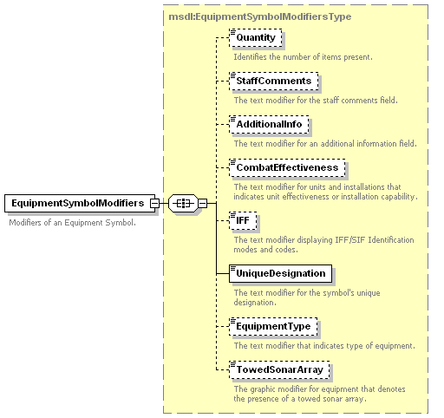
Figure 1. Equipment Symbol Modifier Element
MSDL can be used to interchange initial conditions or state information. Scenario authoring applications can export their internal data representations out to MSDL files. Consuming simulation applications can import MSDL and map the information into their internal data representations for use in initialization.
The OneSAF program contributed heavily to the MSDL standard. OneSAF uses internal battlespace objects to enumerate equipment types in their scenarios [10]. The OneSAF Military Scenario Development Environment (MSDE) tool exports MSDL files that can be imported into the OneSAF Management and Control Tool (MCT) (see Figure 2).
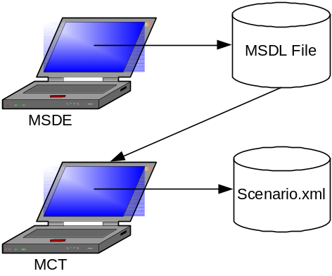
Figure 2. OneSAF MSDE Generates MSDL
OneSAF scenarios are stored as simulation-specific XML files that are similar to MSDL. OneSAF equipment types are tied to equipment compositions that are enumerated values identified by strings.
2.3 Code Lists
Interchange files like MSDL often have elements whose valid values come from a controlled vocabulary of valid values. These code lists are sets of allowed values for a specific variable. An example of a code list is the ISO 3166 [11] country code list or the list of U.S. postal (“zip”) codes.
Genericode is an OASIS-developed neutral representation for describing code lists [12]. It is based on the approach used by the Financial Products Markup Language (FpML) and the Marketing Data Definition Language (MDDL).
2.4 Authoritative Equipment Code Lists
A variety of “publishers” maintain code lists of military equipment. Each publisher has a unique approach for identifying a particular type of equipment and represents a different set of equipment – often at different levels of resolution. A lot of thought and energy goes into maintaining taxonomies, but the translation of one to another is made more difficult by the fact that each taxonomy represents the needs and wants of a specific user and maintainer community. Often these communities act on their own, creating products that are difficult to reconcile. The problem is exacerbated by the sheer size of the taxonomy. Even the highest levels of equipment taxonomies for every equipment type in the world are very large and complex.
2.4.1 Moderated Integrated Database (MIDB) Equipment Codes
MIDB Equipment Codes use 5-digit alphanumeric codes maintained by the Defense Intelligence Agency (DIA). The first 2-3 characters are meaningful to the schema, with the remainder being assigned in order. This schema has recently undergone a major revision. The Equipment Codes themselves are mostly unclassified, but there are some classified ones (~10%) and the database as a whole is classified due to other classified data elements. This schema is primarily intended for use in the U.S. intelligence community but forms the basis of enumerations in simulations such as the U.S. Army’s WARSIM constructive simulation [13].

2.4.2 DIS Enumerations
DIS Enumerations were originally specified for use in Entity State PDUs to identify equipment types. They are documented in “Enumeration and Bit Encoded Values for use with Protocols for Distributed Interactive Simulation Applications, SISO-REF-010-2006/ IEEE Standard 1278.1A” [5]. They are encoded using numeric values maintained in a published document for usage by SISO on behalf of the IEEE Computer Society.
The DIS Enumerations document does not represent a true taxonomy of equipment types because some “leaf” nodes are actual instances of equipment (such as ships) instead of types of equipment. An example of DIS enumerations for an M1A1 (U.S. manufactured) tank platform are show in Table 1.
Table 1. DIS Enumerations for M1A1
Attribute | Title | Value
Kind | Platform | 1
Domain | Land | 1
Country | United States | 225
Category | Tank | 1
Subcategory | M1 Abrams | 1
Specific | M1A1 Abrams | 2
DIS enumerations are sometimes encoded as a string (e.g., “1.1.225.1.1.2”). Machine readable versions of the DIS enumerations have been developed using XML to support automated processing [16].
An equipment ontology was developed as part of the Defense Advanced Research Projects Agency (DARPA) Agent Markup Language (DAML) effort [14]. This ontology was based on the DIS enumeration taxonomy and was encoded using the Web Ontology Language - OWL. Using an OWL ontology, enables consuming applications to use the ontology’s subclass declarations to infer generalization relationships.
2.4.3 JC3IEDM
The Joint Consultation, Command and Control Information Exchange Data Model (JC3IEDM) is a multinational data interchange standard used to support interoperability. JC3IEDM equipment codes are encoded using the Object Type type and the Material Type. JC3IEDM has been used to generate an ontology using OWL [15]. Sample instances from the JC3IEDM documentation are shown in table 2.
Table 2. JC3IEDM Sample Data
materiel-type-id | object-type-name-text
68763 | Challenger MBT
49662 | Abrams MBT
813 | Attack Helicopter, AH-64
6687 | Bradley AFV
2.4.4 Common Code List Characteristics
Code lists are volatile. As new items come into countries’ inventories and old equipment is purged, publishers update their code lists on their own schedule unrelated to MSDL standard updates.
Databases can provide automated support for maintaining these dynamic lists. Eventually, code list databases may become web enabled so that web services can provide access to information on a particular platform class given a unique identifier (key). The Joint Training Confederation (JTC) Database (JDB) stored valid JTC enumerations [3] and a Microsoft Access database was used to implement the DIS Data Dictionary that contains DIS enumerations [16].
2.5 Problem Statement
Symbology standards referenced by MSDL enumerations (i.e., MIL-STD-2525B and NATO APP-6) do not specify detailed equipment types. These details are needed by simulations that differentiate between equipment types in their models. This deficiency was discussed at the Fall 2008 MSDL meetings at the Simulation Interoperability Workshop as an area for improvement.
The MSDL equipment type modifier is a string field that is flexible (it can represent anything) but is too ambiguous for consistent automated interpretation. There is also no way to validate the free form string without a relationship to lists of allowed values. The string value used to uniquely identify an equipment type may not be the best label for presentation to a human in a user interface. A user-friendly title should be associated with the identifier.

3. Requirements for a Solution
The selected approach for encoding equipment types in MSDL files should satisfy several requirements related to what is being represented and how the approach is implemented.
3.1 Data Representation Requirements
The MSDL equipment type identification approach should:
- Support multiple code lists / publishers,
- Support taxonomic and ontological representation,
- Support exercise-specific code lists, and
- Support “non-standard” enumerations.
The approach needs to support popular equipment identification schemes (e.g., DIS enumeration taxonomy). While it would be simpler if there was one authoritative publisher of detailed unclassified equipment type lists, it is unlikely that the diverse existing systems could be replaced within feasible effort and timeframe constraints.
Code list publishers typically organize their equipment descriptions with taxonomies with multiple levels. Taxonomies are helpful for supporting automated generalization and graceful degradation. Eventually, simulation information representations may mature into more formal ontological representations [17]. The selected MSDL approach should support multiple approaches such as ontologies, taxonomies, and encoding schemes.
In particular exercises, the conceptual model for the simulation (even if it is implicit) will limit the supported equipment types. Conceivably, exercise planners might want to develop a code list that represents a subset of values from an authoritative code list that only includes the equipment being supported in an exercise.
Equipment enumeration approaches should be open-ended, including support for “Non-Standard” enumerations such as historical and hypothetical equipment to support historic scenario re-enactments (e.g., 92 Easting) and scenarios containing hypothetical platform types [18].
Recommendations for representing DIS enumerations in machine-readable form have been made [16], but the recommendations have focused on that single code list.
3.2 Implementation Requirements
The selected MSDL solution for encoding equipment references should:
- Support both human and computer readability,
- Support automated validation, and
- Minimize adoption burdens.
Equipment enumeration approaches should support human and computer readability [16]. Code list developers should provide both machine and human readable content. The representation approach should allow access to additional information (e.g., title) to support Graphical User Interfaces (GUIs).
The equipment enumeration approach should support validation to ensure that specified equipment types are in the code list. However, the validation does not necessarily have to occur at the XML schema level. There is a major issue with the current approach of a simple string field because without a tie to an authoritative list there is no way to determine if a specified equipment type is valid.
The selected approach should minimize the adoption burden on publishers, consumers, tool developers, and MSDL maintainers. It should also support mapping between code lists to enable automated translations.

4. Recommended Solution
The following subsections recommend an approach for improving equipment type descriptions in MSDL.
4.1 Code List Concept
The MSDL Product Development Group (PDG) is not the first standards group to wrestle with XML encoding problems. A variety of approaches have been used with XML to restrict values to members of long lists of valid choices.
At one extreme, explicit enumerations could be hard-coded into XML schema files. This approach is reasonable for fairly short stable lists that can be maintained along with the rest of the schemas. However, it is not a good solution for long lists that change because the schemas would be perceived to be unstable.
An alternate approach involves references to an external companion code list file. One implementation of this approach is being formalized and standardized by OASIS in Genericode. Genericode is a meta-schema that specifies a set of elements that can be used to describe the structure and contents of complex code lists [12].
Whenever practicable, standard approaches should be considered and leveraged if not reused. Although adopting Genericode would be an elegant solution that leverages another international standard, the overhead required to fully implement that solution might be unrealistic for the MSDL user community.
A simplified code list encoding approach could be developed that leverages Genericode concepts without implementing the whole standard. A simple code list schema should specify elements for metadata including versioning information and provenance hints. The code list schema should specify elements for encoding the code list information including key values, human-readable labels (names), and parent equipment type pointers.
A simple code list schema could effectively implement a table structure with columns (such as the sample presented in Table 3).
Table 3. Sample Code List Table Contents
Key Field | Title | Parent Type
FIGHT | Fighter | Fixed Wing
F16 | F-16 Fighting Falcon | FIGHT
F16C | F-16C | F16
A URL namespace should be defined for each encoding scheme. For example, a namespace for DIS enumerations could be identified as “www.sisostds.org/ns/disenum”.
4.2 Implementing a Code List With XML
Implementing a simplified code list schema would primarily involve defining an XML code list schema, encoding code lists in compliant XML instance files, and referencing the codes from MSDL scenario files.
A code list XML schema could be developed using concepts from Genericode. The schema should include elements for defining key values, titles, and parent (taxonomical) information. The schema should be managed by the MSDL PDG as a separate XML schema from MSDL files to allow reuse by other SISO standards.
Code list instance files would contain lists of equipment in a form that complied with the simplified code list schema. Taxonomies could be “flattened” into simple tables that reference parent entries. Automated tools (e.g., XMLSpy) could validate that code lists complied with the simple code list schema.
MSDL files would need to identify the code list being used and individual equipment instantiations would need to use the key value for the proper item in the code list. The reference to the code list could be a new scenario level option or could be an attribute of the equipment type. MSDL entries that reference codes could be validated in a separate “second pass” after schema validation.
4.3 Concept of Operations
Adopting the approach above has implications for producers and consumers of equipment type codes.
4.3.1 Publishers
Publishers could provide web site assistance to consumers of their code lists. The namespace for the code list could be represented by a URL. The URL used with the namespace should be resolvable to a web page that provides information about the code list, a human-readable document listing the codes, and a code list XML file that validates against the MSDL Code List schema.
Publishers could continue to maintain their code lists in either document or database form. The document versions of the code lists should be available for humans (and could be produced from databases). The database versions should be used to create XML files for use by automated tools.
Publisher databases could be used to publish an XML view of the subset of the database associated with a particular code list. The XML file should be compliant with the MSDL code list XML Schema standardized by the MSDL PDG. The OASIS Genericode schema could be reused or a simpler subset of Genericode could be developed for MSDL uses.
Publishers could take responsibility for mapping to other code lists. Mapping tables contained in XML files could provide a “Rosetta Stone” for equivalency mappings.
The approach described above supports multiple levels of a taxonomy by first “flattening” the taxonomy into a relational table. By allowing publishers of code lists to specify whatever codes they want, the approach supports historical and hypothetical equipment types.
4.3.2 Code List Consumers
Editing tools populate equipment type fields with references to values in the code list XML files. Code list file can provide user interface information to the editing tools. Consuming software would rely on a key value to uniquely identify the code list entry. Figure 3 shows how a MSDL file could reference a code list file and a particular entry within the file.
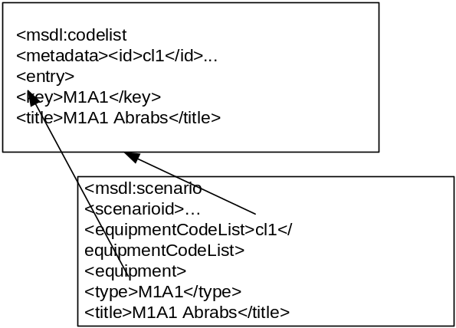
Figure 3. Example Reference to Code List
An exhaustive list of valid choices for equipment types in the code list file enables automated validation. A secondary pass with additional software (that can be incorporated into the editing tools) could compare the values to the ones in the associated code list XML file.
4.3.3 User Readers
A satisfactory approach needs to support human and computer readability. The use of a key field allows computers to access valid choices and access related information (e.g., parent type). The title subelement allows humans to view the name of a particular type.
Figure 4 provides an overview of the code list data flow between publishers and consumers.
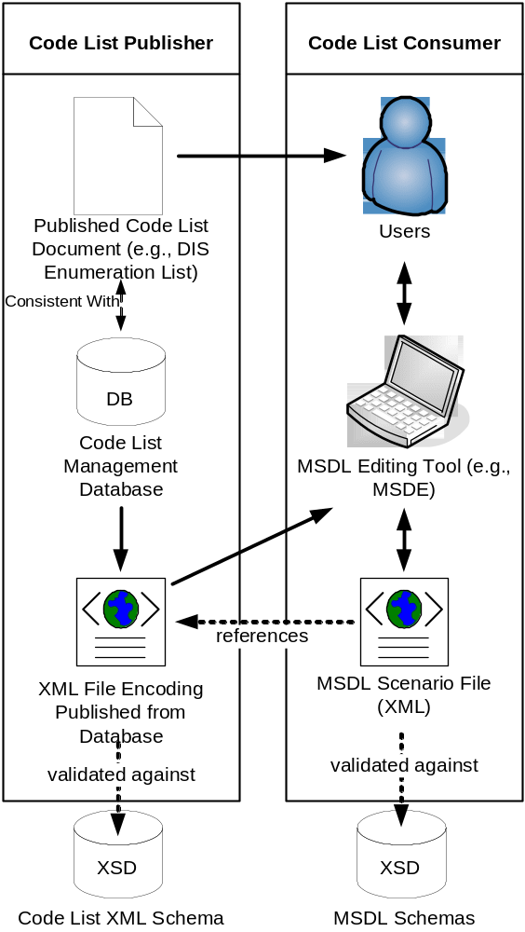
Figure 4. MSDL Files Reference Code List Values

4.4 Specific Recommendations
The following subsection specifies recommendations for the MSDL PDG, publishers, and consumers.
Recommendations for the MSDL PDG:
- Specify a simple code list XML schema,
- Provide guidance on code list population for publishers and use for consumers, and
- Modify the MSDL standard to reference code list and equipment type references to code list entries.

Recommendations for publishers:
- Generate an XML view of their code lists that conforms to the code list standard,
- Provide taxonomy information using parent information, and
- Associate equipment type titles with key values.
Recommendations for consumers:
- Incorporate titles in GUIs and use parent type information to reconstruct hierarchies of choices within GUIs,
- Populate MSDL files correctly with references to the code list being used and references to codes, and
- Automate validation against the code lists.

5. Summary
Equipment enumeration code lists are built and maintained by a variety of publishers. A new solution is needed to support the representation of equipment enumerations in MSDL files. A set of requirements and some ideas for one potential solution have been provided. Although the proposed solution is focused on equipment types, it can be generalized to other code list items in MSDL.

6. References
[1] Standard for: Military Scenario Definition Language (MSDL), SISO-STD-007-2008, 14 October 2008
[2] Lacy, L. and T. Dugone, “Developing International Standards for Interchanging Simulation Data” Proceedings of the 2001 Simulation Interoperability Workshop – Europe, June, 2001.
[3] McFadden, G. J. “An Approach to Management of Enumerated Data in Federations”, Proceedings of the Spring 2000 Simulation Interoperability Workshop, Orlando, FL, March, 2000.
[4] Prochnow, D., “Initialization of Distributed Simulations: A Better Way?” Fall 2005 Simulation Interoperability Workshop, September 2005
[5] Enumeration and Bit Encoded Values for use with Protocols for Distributed Interactive Simulation Applications, SISO-REF-010-2006/ IEEE Standard 1278.1A
[6] MIL-STD-2525B – Common Warfighting Symbology, DoD, 1 July 2005.
[7] Saikou D., W. Civinskas, A. Tolk “An Application Extension for the Military Scenario Description Language”, Spring 2006 Simulation Interoperability Workshop
[8] Wittman, R., Abbott, J. (2006) “Keeping up with the Military Scenario Definition Language (MSDL).” Spring 2006 Simulation Interoperability Workshop.
[9] Blais, C. “Military Scenario Definition Language (MSDL): How Broadly Can It Be Applied?”, Proceedings of the Spring 2008 Simulation Interoperability Workshop, April 2008.
[10] Franceschini, R.W., “Specifying Scenarios Using the Military Scenario Definition Language”, Proceedings of the Spring 2004 Simulation Interoperability Workshop.
[11] ISO 3166-1:2006, Codes for the representation of names of countries and their subdivisions -- Part 1: Country codes
[12] Coates, A.B., “Why are simple code lists so complex?”, XML 2004, available on-line at: http://www.idealliance.org/proceedings/xml04/papers/86/codelists.pdf
[13] Lacy, L., Puhlmann, M., Aviles, G., Randolph, W., Kwon, J., “Challenges in Automating the Provisioning of Parametric Initialization Data to Simulation Applications”, Spring 2003 Simulation Interoperability Workshop.
[14] Lacy, L.W., Gerber, W. J., “Potential Modeling and Simulation Applications of the Web Ontology Language – OWL”, Proceedings of the 36th conference on Winter simulation, 2004.
[15] B. Ulicny, C. Matheus, G. Powell R. Dionne and M. Kokar, Representability of METT-TC Factors in JC3IEDM. 12th International Command and Control Research and Technology Symposium, Newport, RI, June 19-21, 2007.
[16] Ross, P., “Machine Readable Enumerations For Improved Distributed Simulation Initialisation Interoperability”, SimTect 2008, Simulation Conference, 12 - 15 May 2008, Melbourne, Australia
[17] Blais, C., Lacy, L.W., “Semantic Web: Implications for Modeling and Simulation System Interoperability”, Proceedings of the Fall 2004 Simulation Interoperability Workshop, Orlando, FL, September 2004.
[18] Spithill, A. and M. McGarity “A Legacy Military System DIS Implementation: Lessons Learnt From I/ITSEC2001” SimTecT 2002 Simulation Conference, downloaded from: http://www.siaa.asn.au/get/2395360270.pdf

Author Biographies
LEE W. LACY is the business unit director for the Modeling, Simulation, and Training business unit at Dynamics Research Corporation. Dr. Lacy has participated in many DIS Workshops and SIWs. He is currently supporting MSDL extensions for the DARPA Deep Green program..
RICHARD BYRD is an Operations Analyst at Northrop Grumman Corporation. He has supported updates to the DIS Enumeration document since 1993.

